- The Jo Savage Manslaughter Case:
Sheriff Bamonte of Breaking Blue fame and I (See my vitae) are seasoned law enforcement professionals who have reviewed the evidence surrounding the death of Jo Savage in the RPS Parking Garage. We concluded, independently, that there was extraordinary evidence to charge the owners of the RPS Parking Garage with First-Degree Manslaughter (RCW 9A.32.060). Spokane County Prosecutor Steve Tucker failed to follow up on the material given his office by the U.S. Attorney’s Office to review under existing state law involving negligent homicide (See U.S. DOJ press release):
. . . Federal investigators examined the tragic accident of April 2006, which claimed the life of Jo Ellen Savage. At issue is whether faulty maintenance at the garage led to the accident. The review determined there is no federal statute that would address the facts surrounding the accident. Whether the State statutes proscribing negligent homicide have application to these facts is a decision better left to local authorities. Therefore the U.S. Attorney’s Office has forwarded the matter to the Spokane County Prosecutor for review. Prosecutors sought and obtained permission from the court to provide certain limited grand jury materials to Spokane County Prosecutor Steve Tucker for his review.
Contrary to statements of certain officials and media accounts in my opinion there was no review of the evidence or testimony given to a federal grand jury in either the Savage case or the RPS Bond Fraud et al. Asst. U.S. Attorney Westinghouse said in his press release:
After the fact there was a great deal of debate over the assumptions made in the bond proposal. But after examining thousand of records from the civil case and using the tools available to the grand jury we determined there was no criminal case of wrongdoing, . . .
My interpretation of what Mr. Westinghouse said is that they used the subpoena power of a federal grand jury to secure documents. I don’t believe there was any review of the evidence by a federal grand jury in either the RPS bond fraud case or the Savage death. I have asked Sheriff Knezovich to clarify this but he has not responded to my request (See my letter 01-27-09). I also sought clarification of Mr. Westinghouse on this point. Mr. Westinghouse replied to my request via the U.S. Attorney Office’s, Public Affairs Officer Emily Langlie:
Mr. Wright,
I have reviewed this matter with Bob Westinghouse. We are unable to comment further, as we are barred by law from discussing any activities related to the grand jury and its processes. I appreciate this is frustrating for you, but there is simply nothing more we can provide.

I don’t believe the U.S. Attorney’s Office is precluded from disclosing in general terms the level of involvement of a grand jury. I believe Mr. Westinghouse doesn’t wish to dispel the belief that their investigation was reviewed by a grand jury. For this argument see the email exchanges with Ms. Langlie on 11-03-09.
For the record if I had been the case agent assigned to this investigation I would have immediately used the U.S. Attorney’s information as the basis for the issuance of multiple search warrants to be served simultaneously at many Spokane locations to secure the evidence that Mr. Tucker declared was lacking. I would have used the extensive documentation of Tim Connor and Larry Shook to establish probable cause to believe that multiple felonies occurred that directly led to the death of Jo Savage; and to gather the necessary evidence to prove the elements of manslaughter. I would have interviewed witnesses who had direct knowledge of the potential culpability of the garage owners.
The legal elements and burden of proof for manslaughter involve the concepts of ordinary care and/or due diligence that is due all patrons by business property owner(s). Specifically First-Degree Manslaughter in the State of Washington requires, ”. . . recklessly causes the death of another person” (RCW 9A.32.060). General requirements of culpability under WA state law (RCW 9A.08.10) defines reckless as:
RECKLESSNESS. A person is reckless or acts recklessly when he knows of and disregards a substantial risk that a wrongful act may occur and his disregard of such substantial risk is a gross deviation from conduct that a reasonable man would exercise in the same situation.
The owners of The Station Bar in the Providence, RI were held to a similar standard when criminally convicted for the tragic bar fire that killed 100 patrons. In my opinion the complicity and guilty knowledge of the RPS garage owners is even more compelling and egregious than in this bar fire.
The mitigating defense as expressed by the Washington Attorney General’s Office (AG) (See Asst. AG Marlow’s letter 03-27-09) and as selectively quoted by Tucker (See Tucker’s press release 04-03-09) for his decision not to file any criminal charges that these parking barriers met any building code is specious, a red herring and fails the common sense or reasonable man test. Tucker did not hold a formal press conference announcing his decision not to file any charges where he would have questions. Tucker’s office just released a press release to the media. KXLY’s TV Reporter Eric Looney was the only media reporter that interviewed Tucker on camera to ask him about his decision not to file any charges. Tucker told Looney his decision was based partially on the fact that the walls did meet building codes, “. . . proving that someone is criminal negligent or reckless as to the construction of the walls when they meet code is going to be hard to give to a jury.” See the video of Looney’s interview with Tucker.
Whether these barriers met any building code standards is not relevant. The simple fact is these barriers were failing with regularity and the owners knew it. The tragic death of Savage was a foreseeable and likely event for at least fifteen years running. Tucker by his lack of action ensured the Savage case was buried from public view and scrutiny. Tucker announced he would not file any criminal charges in the Savage case at the 11th hour before the statute of limitations ran out. This effectively precluded any other law enforcement agency from doing the necessary criminal investigation to seek criminal charges. Tucker made sure that no impartial jury would ever see and hear the very damning evidence and testimony to decide the guilt or innocence of the owners.
I later filed a public document request (PDR) with the WA AG’s Office and obtained these explosive letters and email from the family of Jo Savage that were apparently dismissed or ignored in the Attorney General’s review of the material submitted by Tucker in addition to the materials that Sheriff Bamonte and I sent. These letters and email were sent by David Savage, the former husband of Jo Savage and a prominent personal injury attorney and former president of the WA State Bar Association, Savage’s current wife Sally Savage, a former senior assistant WA Attorney General, and Rob Rembert of David Savage’s law firm that handled the $1.6M successful civil wrongful death case on behalf of the Savage family.
David Savage wrote:
. . . it is important, however, that all those responsible for this matter understand I firmly believe the information placed in Mr. Tucker’s hands, and now yours [WA AG Rob McKenna](which includes the fruits of my work, the work of the United States Attorney for the Western District of Washington, the Federal Bureau of Investigation and a Grand Jury), clearly describes culpable criminal conduct [Emphasis added]. The owners of the garage knew for years prior to Jo’s death of the very structural infirmity that resulted in it. Nevertheless, they chose not to correct the problem.
Rob Rembert also sent a letter to Tucker offering the Savage law firm’s entire civil case file. David Savage also shared Rembert’s letter with the AG’s Office and Governor Christine Gregoire. Rembert wrote Tucker:
On behalf of the Savage family, I write to offer assistance from our files which support the settlement we achieved on the claims of one million six hundred and ten thousand dollars ($1,610,000.00) with the insurers for the Cowles. Based upon our investigation, it is clear that the owners of the parking garage had longstanding and detailed knowledge that the spandrels were likely to fail as the result of foreseeable vehicular contact. Despite this knowledge, the owners took no corrective action notwithstanding the fact that several engineers recommended it well prior to Ms. Savage’s death. . . . [Emphasis added]
Despite the fact that more than sixteen years had elapsed between the time of the first occurrence of which we know and April 2006 and several engineering recommendations had been made to revise the spandrels, the owners took no action to address this serious public safety issues of which they had specific knowledge.
Given these facts, I trust you can understand why we feel strongly that this matter warrants a careful criminal investigation. Because of the Cowles’ prominence and the City’s involvement with the garage [it] is imperative that your investigation be supported by the Washington State Patrol, a law enforcement agency of the highest integrity. . . [Emphasis added]
. . . These files include a careful reconstruction of the occurrence by John Habberstad, Ph.D, of Origin Engineering, who concluded that the speed of Ms. Savage’s vehicle on contact was less than five miles per hours (a speed and impact insufficient to deploy the vehicle’s air bags). Our files contain extensive photographs of Mrs. Savage’s vehicle, the garage, and the failed spandrel. We also have copies of all of the media video coverage at the time of the occurrence. Finally, we have a number of witness declarations and extensive interview notes.
I wrote both Spokane County Sheriff Knezovich and Spokane Police Chief Anne Kirkpatrick on 01-27-09 that Tucker was setting up the Savage case to fail and demanded that they compel a complete and thorough criminal investigation be done. No such investigation was ever done as confirmed by a letter I received from the Sheriff’s Department in response to a PDR. I also wrote both the AG’s Office and Tucker several times expressing my concerns that no complete and thorough criminal investigation had been done (See my letter of 04-21-09 to WA Asst. AG Marlow). I gave them constructive notice that any filing decision without having a complete and thorough criminal investigation to review would be flawed and disingenuous at best. In my letters I listed several statutory means by which the AG’s Office could have gained jurisdiction in the Savage case.
WA Asst. AG Marlow never responded to my letter of 04-21-09. Marlow is the one who reviewed on behalf of AG Rob McKenna the material Tucker sent for review. I wrote Marlow again on 10-27-09 in light of the discovery of the Savage family letters. Marlow hasn’t responded to my letter. In my letter I asked the following questions:
Why did you not choose to use the statutory mechanisms that both Sheriff Bamonte and I suggested in our correspondence under which your office could be given jurisdiction so you would have the benefit of an independent, complete and thorough criminal investigation to base your filing decision on?
With the letters in your file including the explosive civil deposition of Rex Franklin and the letters from the Savage family, why didn’t you compel Tucker to [do a] complete criminal investigation perhaps by the Washington State Patrol as asked for by the Savage family, before you would issue an advisory opinion for Tucker?
Did you or your staff ever call the Savage family or meet with them after your review as asked by Sally Savage?
Did you send your letter of 03-27-09 or convey its contents to anyone else other than Tucker?
[Note: See discussion/evidence regarding the apparent gratuitous release by Tucker of his decision not to file any criminal charges to KHQ TV (A Cowles Co) at least four days in advance of any other media in my letter of 10-27-09]
Will the AG’s Office ever issue a press release to counter Tucker’s misleading of the public regarding your review of the Savage Case?
While Tucker was truthful in his remarks/findings, he lied by omission by severely limiting the AG’s review of the Savage case. It is true there was insufficient evidence to warrant a criminal filing in this case as both the AG’s Office and Tucker were to conclude, but only because Tucker illegally withheld the sufficient information he gave the AG’s Office that was in his possession. Tucker failed to ensure/compel that a complete and thorough criminal investigation was done of the Savage death. The necessary probative questions of percipient witnesses were never asked, that would have in our opinion obtained the requisite criminal knowledge of the owners to file criminal charges that Tucker found so conveniently lacking. Thus Tucker obstructed justice. Tucker perpetrated a fraud on the public by succumbing to the Cowles Co’s influence and interests. In short Tucker threw this case just as a prizefighter would throw a title fight.
The AG’s Office stated it was preempted by Tucker’s actions from doing its own independent criminal investigation as requested by the Savage family. I personally spoke with Asst. AG Scott A. Marlow who reviewed Tucker’s materials on behalf of AG Rob McKenna and wrote Tucker about the AG’s finding. As explained by Marlow, the AG’s review was based solely on materials submitted by Tucker for their review (See Marlow’s letters of 03-13-09 and 03-27-09). Attorney General Rob McKenna and Asst. AG Marlow chose not to pubically expose Tucker’s manipulation of the AG’s review. The evidence clearly shows that the state AG and Tucker conspired to illegally withhold evidence supporting the filing of manslaughter charges in the death of Jo Savage. The Savage law firm put both parties on notice of their illegal actions.
The evidence supports two critical conclusions. 1) Tucker effectively tied the AG’s hands. 2) The AG let its hands be tied, because it was given independent knowledge by the Savage law firm of Tucker’s illegally withheld evidence. Tucker knew he was manipulating the AG, and the AG knew it too. It is now clear that actions of the AG’s Office and Tucker were not merely flawed but willfully criminal. I believe these actions by Tucker and the AG effectively aided and abetted this ongoing criminal enterprise whose actions led directly to Jo Savage’s death. This is public corruption of the most alarming degree and it cries out for correction.
Tucker made himself a party to the criminal activities that may still threaten an unsuspecting public. Underscoring the repugnance of Tucker’s action, the Cowles-owned Spokesman-Review has twice endorsed him for the Office of County Prosecutor. Of course the Cowles family supports Tucker. He has guaranteed Cowles family members would not be brought to justice in the matter of Savage’s death. In my opinion Tucker, by his action, rendered criminal assistance (RCW 9A.76.070) to an ongoing criminal enterprise led by the Cowles Co. as defined in the Federal RICO Act. See the U.S. Department of Justice’s RICO prosecution manual (4th Edition July 2000) for RICO actions.
I filed a formal criminal complaint against Tucker with Governor Christine Gregoire alleging Tucker rendered criminal assistance to this criminal enterprise and requested she act under her statutory authority to compel a criminal investigation. Governor Gregoire never responded to my complaint.
The Spokesman-Review (S-R) owned by the Cowles Co has conspicuously avoided educating and informing the public on the Savage death while at the same time with the investigative zeal characteristic of the free press has doggedly followed the death of Otto Zehm at the hands of the Spokane Police Department. Why? The S-R City Editors including the S-R’s political/governmental reporters were sent the Savage family letters by me on 06-17-09 and again on 10-27-09. As of the date of this brief, there hasn’t been a follow up story on the significance of these Savage family letters. Why?
Gary Graham, S-R Editor, earlier emailed Larry Shook of Camas Magazine requesting that he remove the very damning Franklin photo (see below) from the Girl from Hot Springs web site for copyright infringement. Why?
Larry,

It has just been brought to my attention that the girlfromhotsprings
website has at least three of our photos posted on it. We never
authorized such use. It would appear that you are in violation of
copyright laws because all of our published photos and stories are
copyrighted each day.

I am referring to the 1991 photo of Rex Franklin and the two later
photos of the exterior of the parking garage.

I respectfully ask that you remove the photos from your site
immediately. If they are being used in a proposed book, they should be
removed. You do not have our permission to use the photos.

Regards,

Gary Graham
Editor
The Spokesman-Review

When I first saw this photo I immediately recognized it was crucial evidence in the Savage manslaughter case. This photo is direct evidence that this was a serious imminent public hazard that had existed from at least 1991. The owners were well aware of this hazard that these parking barriers were failing on average one to three times per year in the decade preceding Savage’s tragic death. In fact two previous vehicles broke through these parking barriers and were left hanging on their undercarriages in the intervening years. The owners did nothing to mitigate this imminent hazard over the ensuing years as stated by both David Savage and Rob Rembert in part from the explosive civil deposition of Rex Franklin, a former RPS Parking Garage manager, who appears in this 1991 S-R archive photo:
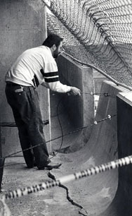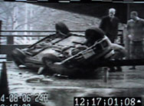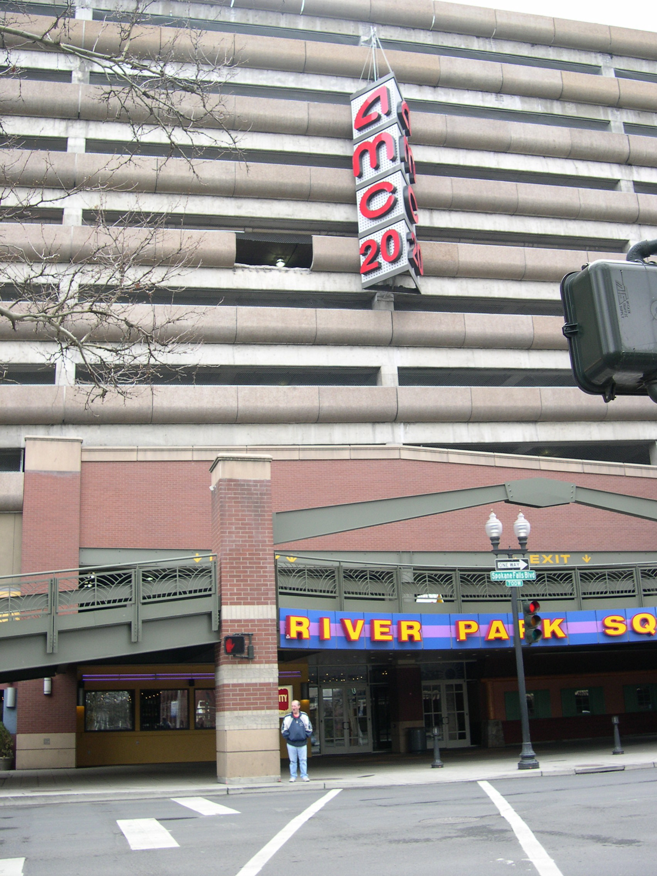
(Left) Spokesman-Review archive photo circa 1991 showing a RPS Parking Garage vehicle barrier that failed in similar fashion as the one that broke in 2006 causing Jo Savage to fall on April 8, 2006. (Center) Savage’s vehicle as it came to rest on the

